**Tutorial - Class Activity (Solution)**

**19 September, 2018**





**Solution**

The strategy of buying a call (or put) and selling a call (or put) at a higher strike is called call (put) bull spread. In order to draw the profit diagrams, we need to find the future value of the cost of entering in the bull spread positions. We have:

Cost of call bull spread: ($120.405 − $93.809) × 1.02 = $27.13

Cost of put bull spread: ($51.777 − $74.201) × 1.02 = −$22.87

The payoff diagram shows that the payoffs to the put bull spread are uniformly less than the payoffs to the call bull spread. There is a difference, because the put bull spread has a negative initial cost (i.e., we are receiving money if we enter into it). The difference is exactly $50, the value of the difference between the two strike prices. It is equivalent as well to the value of the difference of the future values of the initial premia.

Yet, the higher initial cost for the call bull spread is exactly offset by the higher payoff so that the profits of both strategies are the same. It is easy to show this with the put-call-parity.

Payoff diagram:

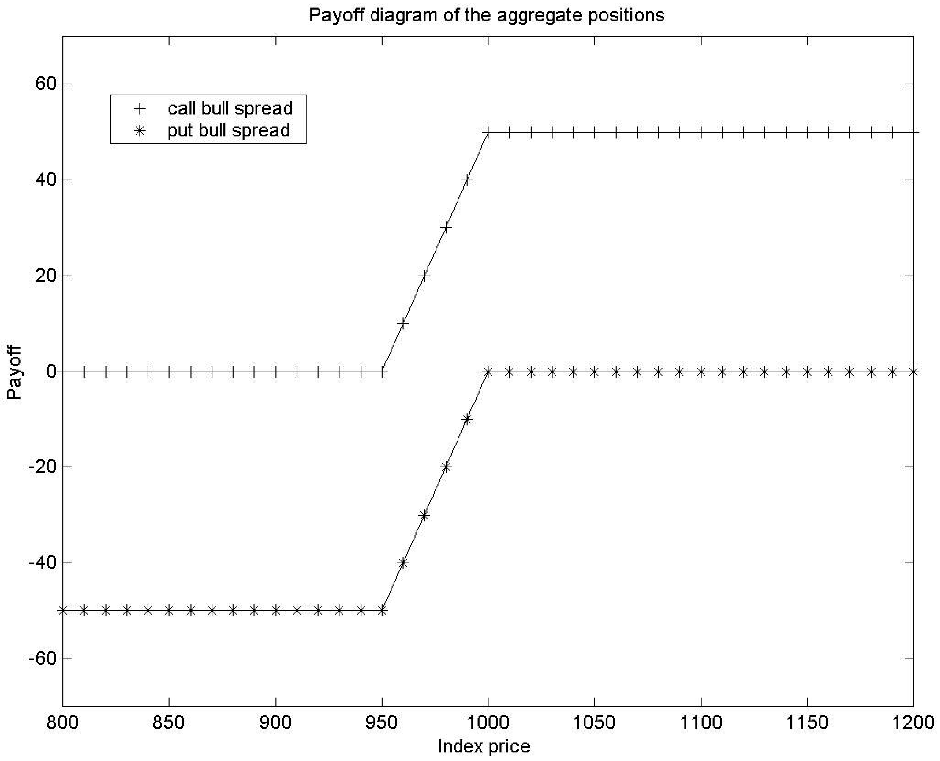

Profit diagram:

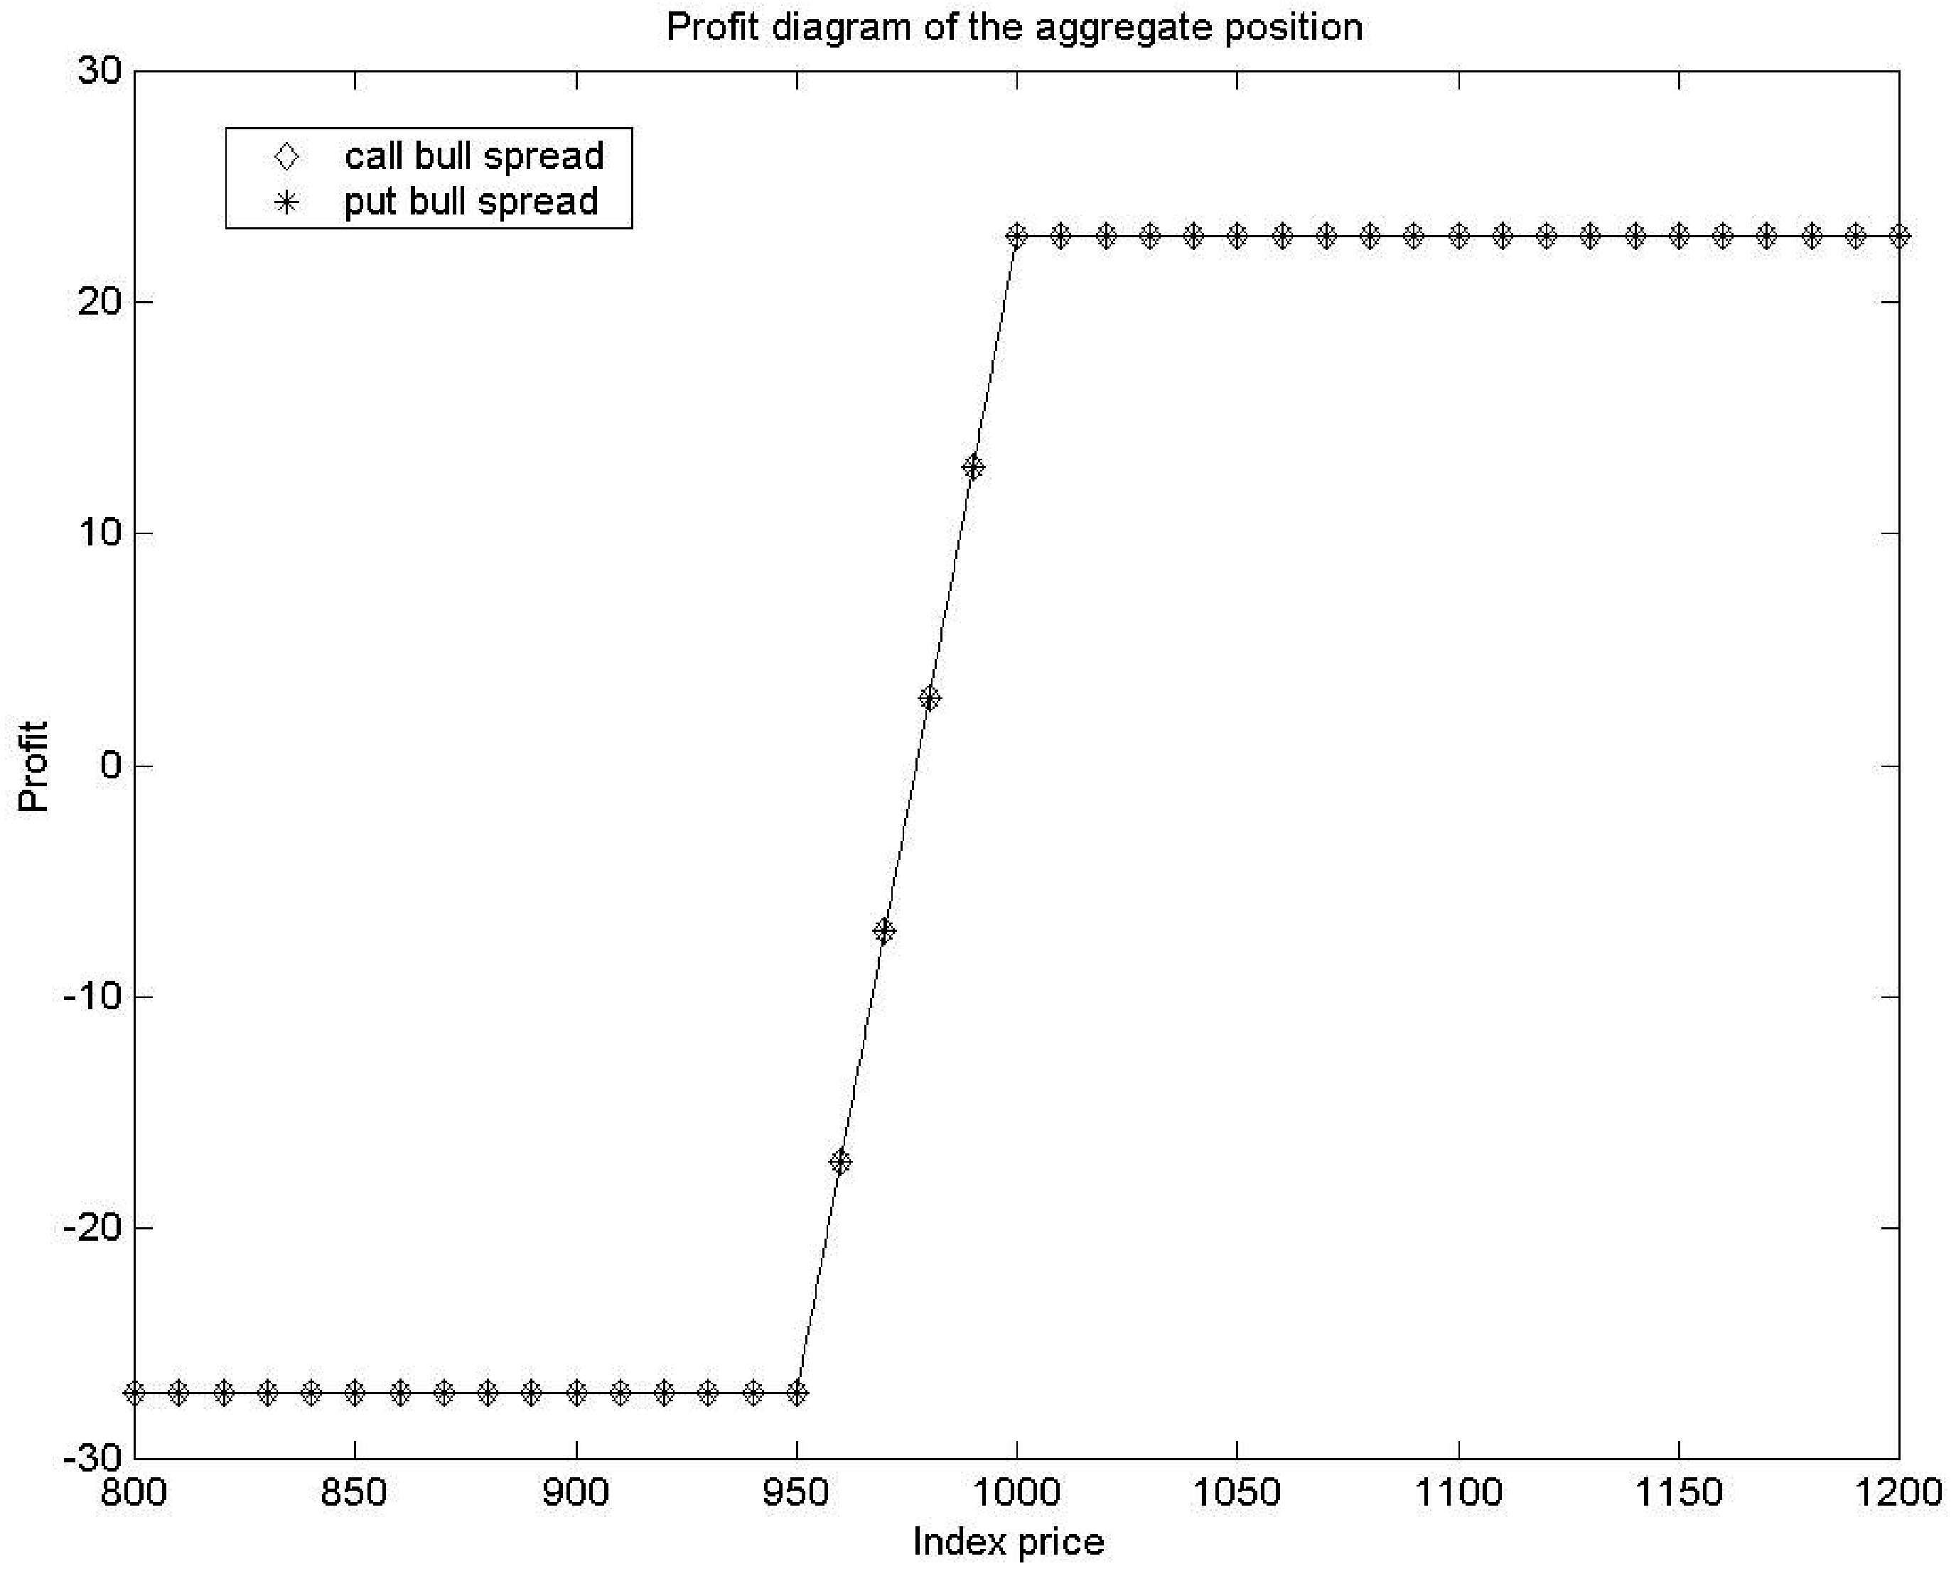

**Proof by using the put-call parity**

Let Call(*K*, *t*) and Put(*K*, *t*) denote the premiums of options with strike price *K* and time *t* until expiration, and *F*0,*t* be the forward price at time 0 with time to expiration of *t*.

The put-call parity states that



So, we have



At maturity of the options, the time until expiration is 0.

At time 0, the time until expiration is *T*.

The payoff of the call bull spread is then given by



The cost of the call bull spread at time 0 is then given by



The profit of the call bull spread at *T* is then given by



1. The current price of a non-dividend paying stock is $40 and the continuously compounded annual risk-free rate of return is 8%. The following table shows call and put option premiums for three-month European options of various exercise prices:

|  |  |  |  |
| --- | --- | --- | --- |
|  | Exercise Price | Call Premium | Put Premium |
|  | $35 | $6.13 | $0.44 |
|  | $40 | $2.78 | $1.99 |
|  | $45 | $0.97 | $5.08 |

A trader interested in speculating on volatility in the stock price is considering two investment strategies. The first is a 40-strike straddle – i.e., purchase of one 40-strike call option and one 40-strike put option. The second is a strangle consisting of purchasing of one 35-strike put and one 45-strike call.

Determine the range of stock prices in 3 months for which the profit of the strangle is greater than the profit of the straddle in 3 months.

**Solution**

The straddle consists of buying a 40-strike call and buying a 40-strike put.

The cost of the straddle = 2.78 + 1.99 = 4.77.

The future value of the cost of the straddle at three months = 4.77*e*8%×0.25 = 4.87.

The strangle consists of buying a 35-strike put and buying a 45-strike call.

The cost of the strangle = 0.44 + 0.97 = 1.41.

The future value of the cost of the strangle at three months = 1.41*e*8%×0.25 = 1.44.

Let *S*0.25 be the stock price in three months.

The **payoff table** for the straddle and strangle at three months can be obtained as follows:

|  |  |  |  |  |
| --- | --- | --- | --- | --- |
|  | *S*0.25 < 35 | 35 ≤ *S*0.25 < 40 | 40 ≤ *S*0.25 < 45 | *S*0.25  ≥ 45 |
| Buy a 40-strike call | 0 | 0 | *S*0.25  − 40 | *S*0.25  − 40 |
| Buy a 40-strike put | 40 – *S*0.25 | 40 – *S*0.25 | 0 | 0 |
| **The payoff of the straddle** | 40 – *S*0.25 | 40 – *S*0.25 | *S*0.25  − 40 | *S*0.25  − 40 |
| Buy a 35-strike put | 35 – *S*0.25 | 0 | 0 | 0 |
| Buy a 45-strike call | 0 | 0 | 0 | *S*0.25  − 45 |
| **The payoff of the strangle** | 35 – *S*0.25 | 0 | 0 | *S*0.25  − 45 |

Hence, the **profit table** for the straddle and strangle at three months is

|  |  |  |  |  |
| --- | --- | --- | --- | --- |
|  | *S*0.25 < 35 | 35 ≤ *S*0.25 < 40 | 40 ≤ *S*0.25 < 45 | *S*0.25  ≥ 45 |
| **The profit of the straddle (A)** | 40 – *S*0.25 – 4.87  = 35.13 – *S*0.25 | 40 – *S*0.25 – 4.87  = 35.13 – *S*0.25 | *S*0.25  − 40 – 4.87  = *S*0.25  − 44.87 | *S*0.25  − 40 – 4.87  = *S*0.25  − 44.87 |
| **The profit of the strangle**  **(B)** | 35 – *S*0.25 – 1.44  = 33.56 – *S*0.25 | – 1.44 | – 1.44 | *S*0.25  − 45 – 1.44  = *S*0.25  − 46.44 |
| **(A) – (B)** | 1.57 | 36.57 – *S*0.25 | *S*0.25  – 43.43 | 1.57 |

The profit of the strangle is higher than the profit of the straddle in 3 months if (A) – (B) < 0. Hence, the strangle **CANNOT** outperform straddle in 3 months when *S*0.25 < 35 and *S*0.25  ≥ 45.

When 35 ≤ *S*0.25 < 40, the strangle will outperform the straddle if

36.57 – *S*0.25 < 0 or *S*0.25 > 36.57.

Combining with 35 ≤ *S*0.25 < 40, we have 36.57 < *S*0.25 < 40. (I)

When 40 ≤ *S*0.25 < 45, the strangle will outperform the straddle if

*S*0.25 – 43.43 < 0 or *S*0.25 < 43.43.

Combining with 40 ≤ *S*0.25 < 45, we have 40 ≤ *S*0.25 < 43.43. (II)

From (I) and (II), the strangle will outperform the straddle when

36.57 < *S*0.25 < 43.43.